Define Total Utility and Marginal Utility. Explain the relationship between TU and MU.

Total Utility (TU): It is the total satisfaction obtained from the consumption of a given units of a commodity by a consumer within a given time period. In other words, It is the sum of Marginal utility (MU).
TU = ∑MU
Marginal Utility (MU): It is the additional satisfaction that the consumer get from the consumption of one extra unit of the commodity. Alternatively, MU is defined as the change (addition) in Total Utility when one more unit of a commodity is consumed.
i.e, MU = $\frac{∆TU}{∆Q}$
where, ∆TU = change in total utility
∆Q = change in units of a commodity consumed
MU can also be written as: MU = TU_{n} – TU_{n-1}

Relationship between TU and MU.
Units of apple | TU  (in Utils) | MU  (in Utils) | Relation between TU and MU
1 | 10 | 10 | MU is declining but positive and TU is increasing
2 | 18 | 8 | MU is declining but positive and TU is increasing
3 | 24 | 6 | MU is declining but positive and TU is increasing
4  5 | 28  30 | 4  2 | MU is declining but positive and TU is increasing
6 | 30 | 0 | MU is zero and TU is Maximum
7 | 28 | -2 | MU is negative and TU is declining

Graphically,
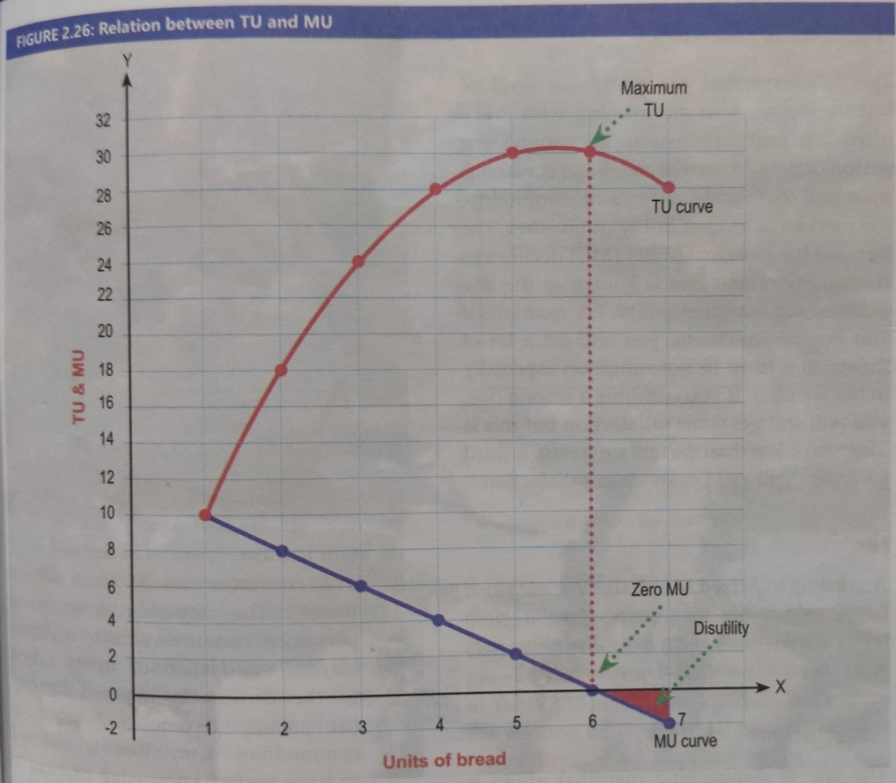

Explanation of the table and figure:
As shown in table and figure above, Upto 5th units of apple consumed, marginal utility is declining but remains positive and Total Utility increases at an decreasing rate. As the consumer consumes 6th unit of a commodity, MU becomes zero the Total Utility becomes maximum. Thereafter, Marginal Utility becomes negative and Total Utility begins to decline.
(Only for NOTE: Point of satiety/saturation point is the point where the consumer gets maximum satisfaction.)
Relation between TU and MU:
- TU is sum of MU whereas MU is the change in TU.
- TU generally remains positive while MU may be positive, zero or even negative.
- When MU is declining but positive, TU is increases at a decreasing rate.
- When MU becomes zero, TU becomes maximum.
- When MU becomes negative, TU begins to fall.

