Price and output determination under monopoly market in the short and long run.
Monopoly market is such type of market structure where there is single seller, product is unique and there is barriers to entry.
Features/Characteristics:
- There is a single seller and large number of buyers.
- The product is unique (i.e, there is no close substitute of the product that the monopolist firm produces).
- There is barriers to entry for new firms
- Monopolist firm is price maker.
- Price discrimination is possible. (This means the monopolist firm can charge different price for its same product.)
Price and output determination in the short run by monopolist firm:
Two approaches:
- TR-TC Approach
- MR-MC Approach

- TR- TC Approach:
Under TR-TC Approach, the monopolist firm will be in equilibrium (i.e, maximizes its profit) at that level of output where the gap between TR and TC is positive and maximum as in figure below:
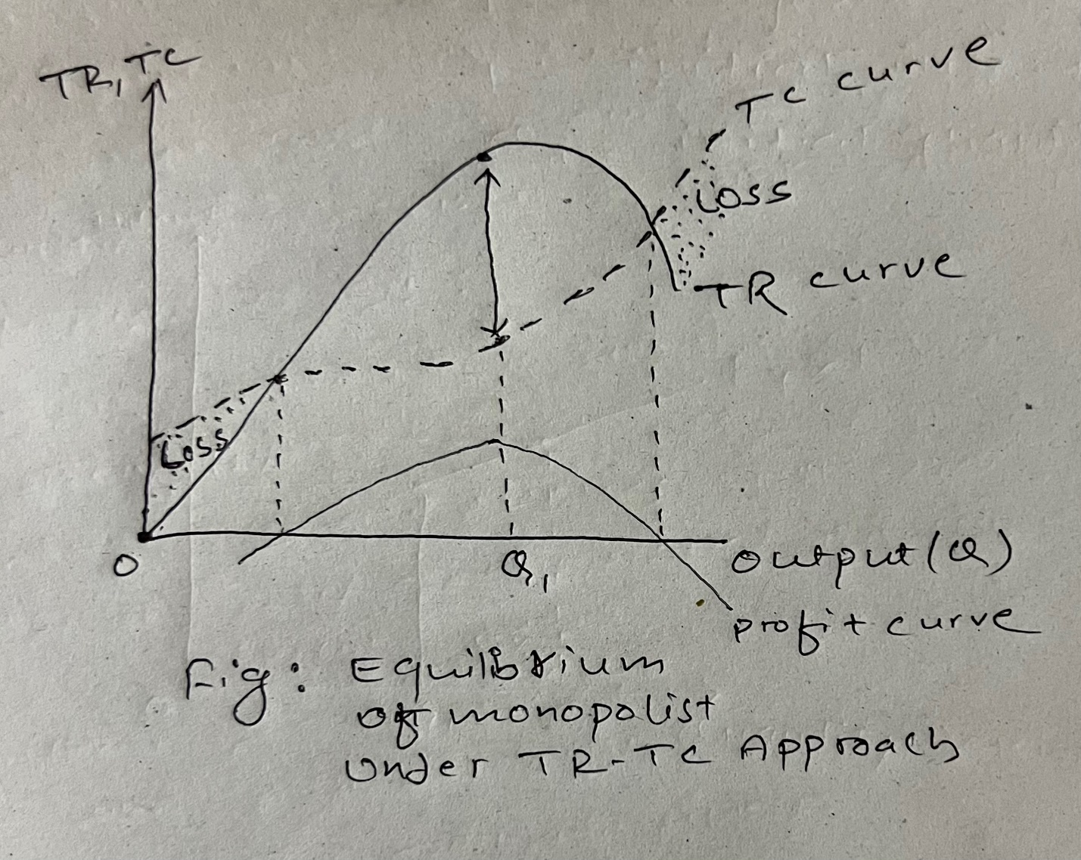

As in figure above, under TR-TC approach, the monopolist is in equilibrium at Q₁ level of output where the gap between TR and TC is positive and maximum.
- MR-MC approach:
Under MR-MC approach, the monopolist firm is said to be in equilibrium in the short run where the following two conditions are satisfied simultaneously:
- First order/necessary condition: MR=MC
- Second order/sufficient condition: The MC must cut the MR from below (i.e, slope of MC > slope of MC)
In case of short run, the monopolist firm will be in equilibrium earning excess(abnormal) profit, normal profit or even incurring losses which depends upon AR and AC at equilibrium output.
If AR >AC at equilibrium output excess profit
If AR = AC at equilibrium output Normal Profit
If AR < AC at equilibrium output Losses
The short run equilibrium of the monopolist under MR- MC approach can be explained with the help of following figure:
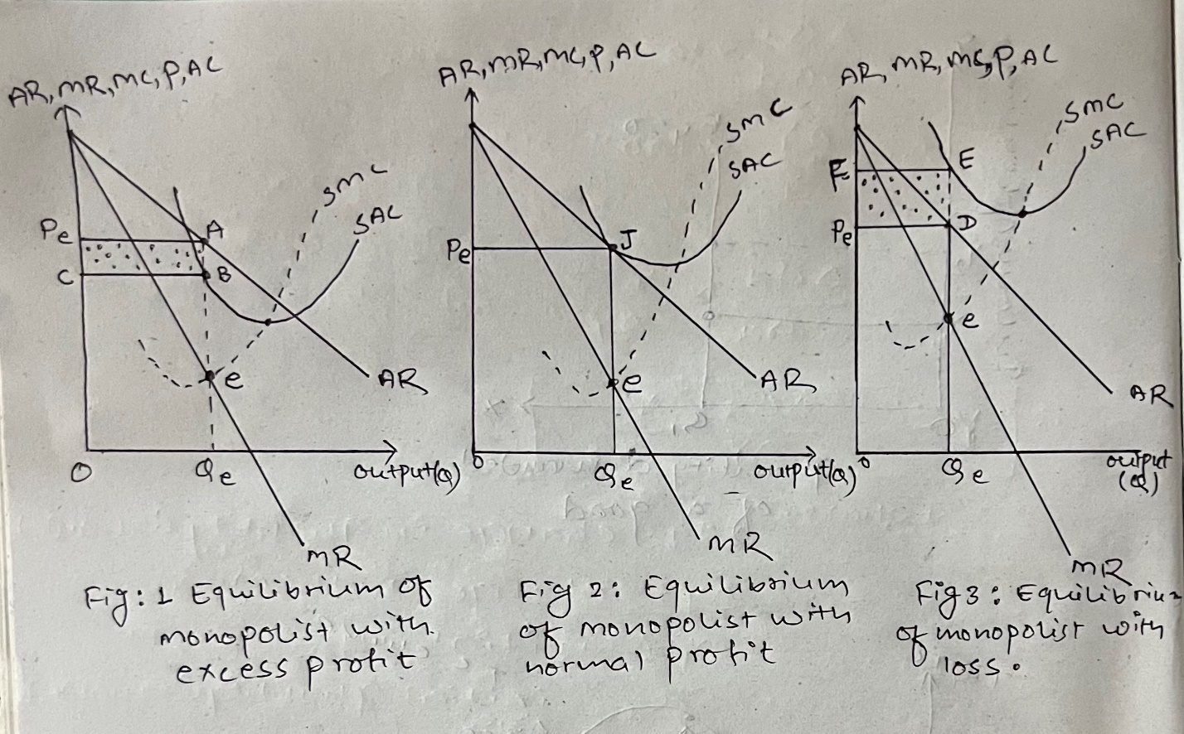
As shown in figure 1, the monopolist firm is in equilibrium at point ‘e’ where both the conditions for equilibrium are satisfied simultaneously. As such the equilibrium price OP_{e} and equilibrium quantity OQ_{e} is determined. Since AR (i.e, AQ_{e}) is greater than AC (i.e, BQ_{e}) at equilibrium output, the monopolist firm is in equilibrium earning excess profit equal to area □ABCP_{E} .
Similarly, as shown in figure 2, the monopolist firm is in equilibrium at point ‘e’ where both the conditions for equilibrium are satisfied simultaneously. As such the equilibrium price OP_{e} and equilibrium output OQ_{e} is determined. Since AR = AC at equilibrium output, the monopolist firm is in equilibrium earning normal profit.
Similarly, as shown in figure 3, the monopolist firm is in equilibrium at point ‘e’ where both the conditions for equilibrium are satisfied simultaneously. As such the equilibrium price OP_{e} and equilibrium output OQ_{e} is determined. Since AR < AC at equilibrium output, the monopolist firm is in equilibrium incurring losses.

Long run equilibrium of the Monopolist
In case of long run, the monopolist firm can change the size of the plant at that level of output where he can earn excess profit. Since entry is strictly barred, the monopolist firm always earn excess profit in the long run.
To be in equilibrium in the long run the following two conditions must be satisfied:
- MR= LMC
- MC must cut the MR from below
The long run equilibrium of the monopolist can be explained with the help of figure below:
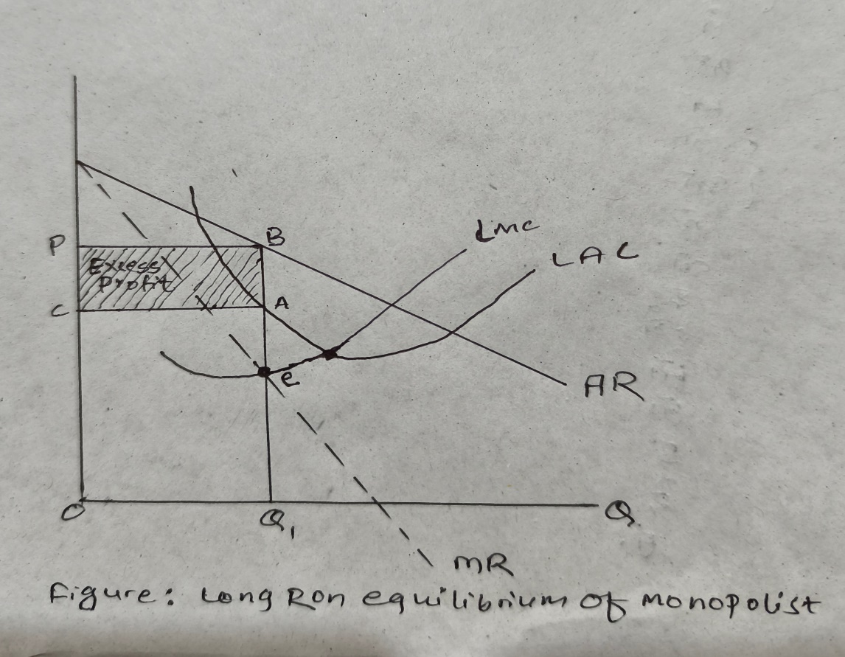
Figure: long run equilibrium of the monopolist firm

As shown in figure above, the monopolist firm is in equilibrium at point ‘e’ where both the conditions for long run equilibrium are satisfied simultaneously. Accordingly, the equilibrium price OP and equilibrium output OQ₁ is determined. As shown in figure, the monopolist firm is in equilibrium earning the excess profit equal to the area □CABP.

