Income elasticity of Demand (E_{y})
Income elasticity of demand is defined as the percentage change in quantity demanded of a good due to some given percentage change in income of the consumer, other things remaining the same.
E_{y} = $\frac{percentage change in quantity demanded of a good}{percentage change in income of the consumer}$

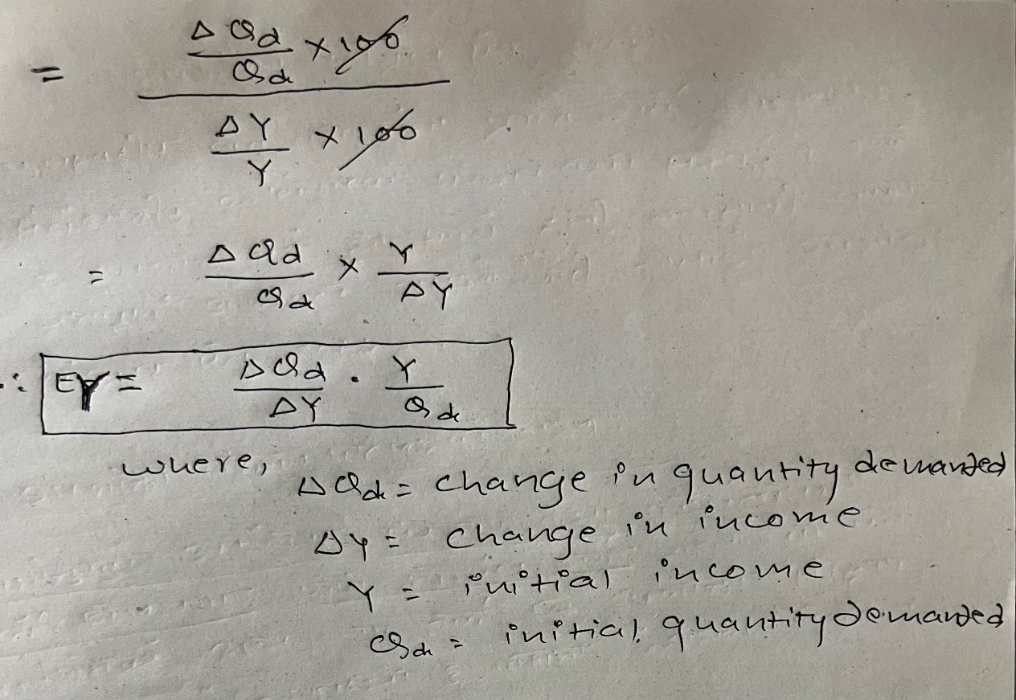
Types:
- Positive income elasticity of demand (E_{y} > 0)
If there is positive relationship between percentage change in income of consumer and the percentage change in quantity demanded of a good, then it is known as positive income elasticity of demand. In case of normal good, the income elasticity of demand is positive.
- Income elasticity of demand greater than one (E_{y}>1):
If the percentage change in quantity demanded of a good is greater than the percentage change in income of consumer, then it is known as income elasticity of demand greater than one.
In case of E_{y}>1, the income demand curve is positively sloped and more flatter as below:
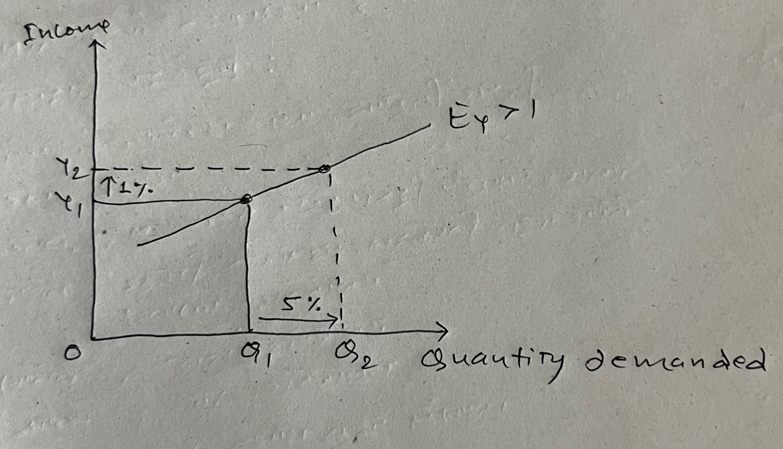

- Income elasticity of demand less than one (E_{y}<1):
If the percentage change in quantity demanded of a good is less than the percentage change in income of consumer, then it is known as income elasticity of demand less than one.
In case of E_{y}<1, the income demand curve is positively sloped and more steeper as below:
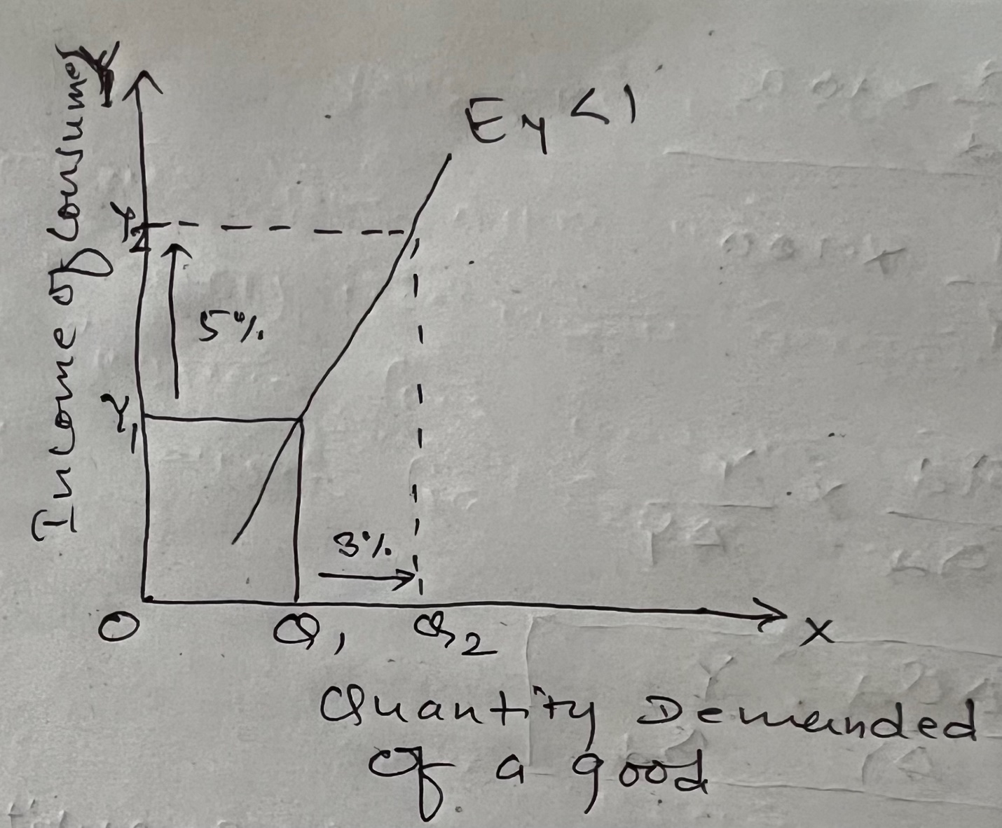
- Income elasticity of demand equals to one (E_{y}= 1)
If the percentage change in quantity demanded of a good is exactly equals to the percentage change in income of consumer, then it is known as income elasticity of demand equals to one.
In case of E_{y}=1, the income demand curve is positively sloped and it is neither flatter nor steeper as below:
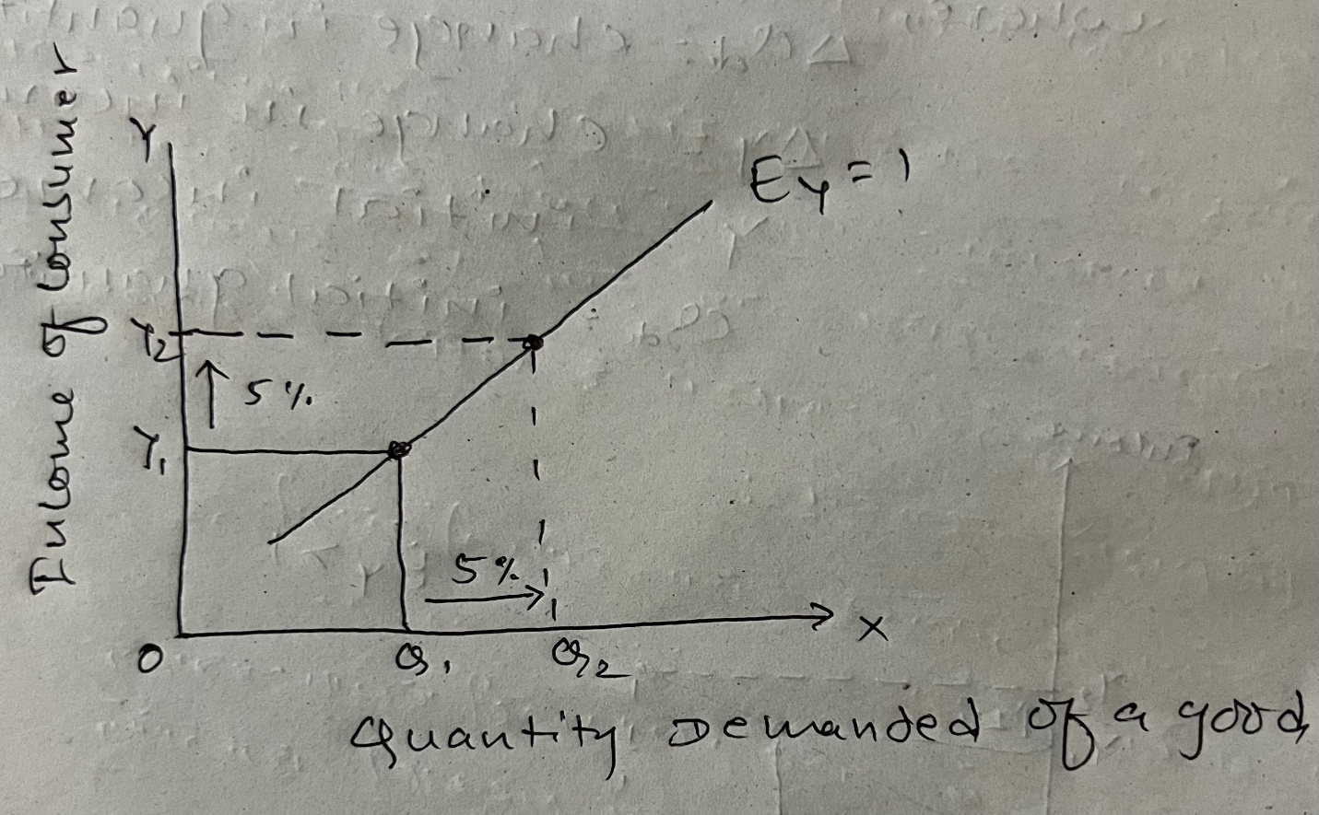
- Negative income elasticity of demand ( E_{y} <0)
If the percentage change in income of consumer and the percentage change in quantity demanded of a good are negatively related, then it is known as negative income elasticity of demand.
In case of inferior good, the income elasticity of demand is negative. So, In case of E_{y}<0, the income demand is negatively sloped as below:
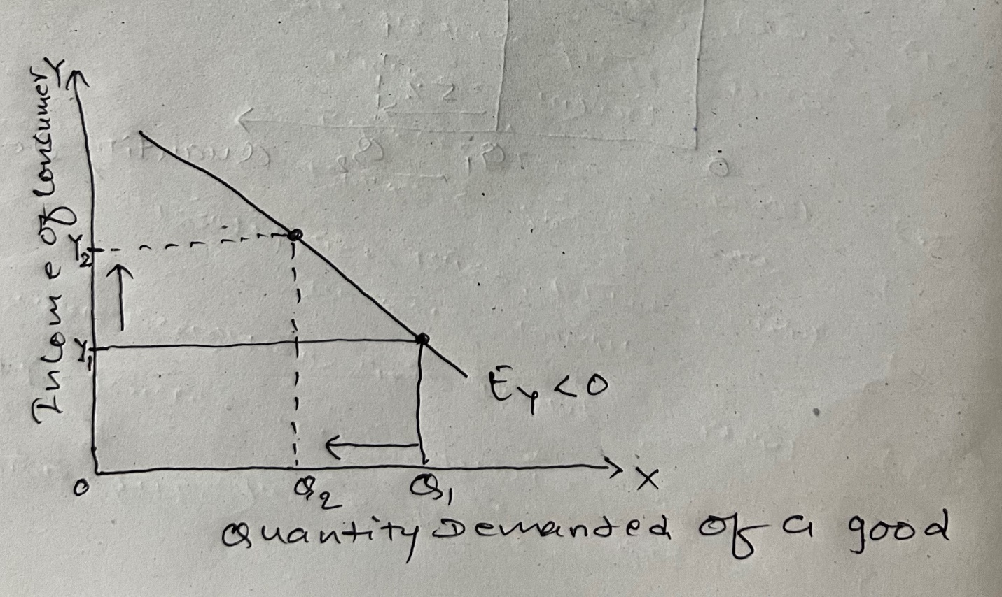
- Zero income elasticity of demand ( E_{y} = 0)
If the quantity demanded of a good is totally irresponsive to whatever percentage change in income of consumer, then it is known as zero income elasticity of demand.
In case of necessary goods such as salt and medicine, the income elasticity of demand is negative.
In case of E_{y} = 0, the income demand curve is vertical and parallel to Y- axis as below:
