Explain the concept of Production Possibility curve (PPC).
It is the graphical representation that shows the maximum possible combination of two goods that an economy can produce with the full-utilization of available resources within the economy. PPC is also called production possibility frontier or product transformation curve.
Assumptions:
- Economy produces only two goods, say, consumer goods and capital goods.
- There is full employment of resources.
- Production technology is given and constant.
- Factors of production are given and constant.
- Time period is given.
On the basis of these assumptions, Production Possibility curve can be explained with the help of table and figure as below:
Production Possibility Schedule
Combinations | Consumer  Goods  (in Units) | Capital  Goods  (in Units) | Opportunity cost
A | 0 | 15 | -
B | 1 | 14 | 1
C | 2 | 12 | 2
D | 3 | 9 | 3
E | 4 | 5 | 4
F | 5 | 0 | 5

Assume that economy only produces two goods i.e, consumer goods and capital goods. As shown in table above, combination A (0,15) shows that if all resources are fully utilized in the production of capital goods only, economy can produce 15 units of capital goods and 0 unit of consumer goods. Similarly, combination F (5,0) shows that if all resources are fully utilized in the production of consumer goods only, economy can produce 5 units of consumer goods and 0 units of capital goods. Other combinations show that the economy can produce a combination of both. As shown in table above, due to the scarcity of resources, as we increase the production of consumer goods, we have to sacrifice the production of capital goods.
Graphically,
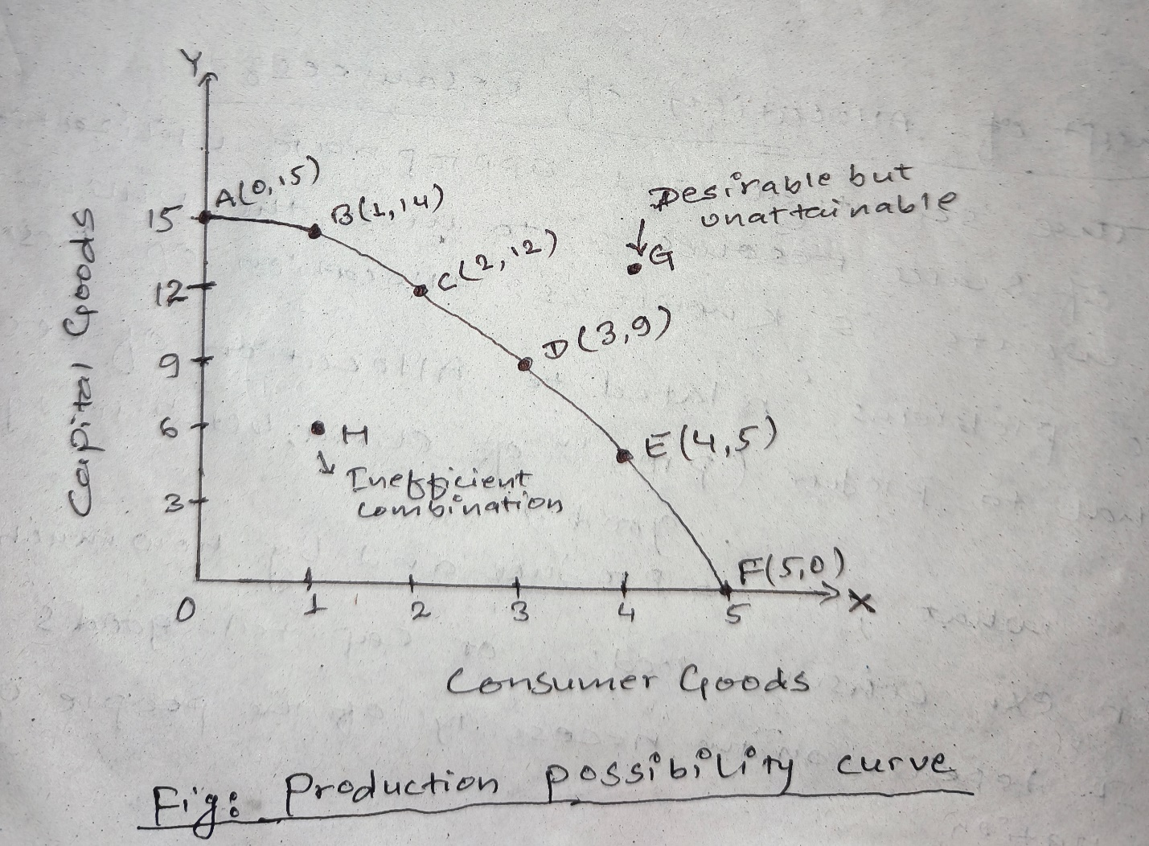

As shown in figure above, quantity of consumer goods are measured in X-axis and quantity of capital goods are measured in Y-axis. AF is the Production Possibility Curve which shows the various combination of two goods (consumer goods and capital goods) that an economy can produce from the full utilization of available resources in the economy.
As the economy moves from one combination to another, production of consumer goods increases while the production of capital good decreases. This implies that more and more amount of consumer goods can not be increased without reducing the production of capital goods due to scarce resources.
All the combination on PPC are efficient. Combinations inside the PPC (such as point H in figure) are inefficient combination. Combination outside the PPC (such as point G in figure) are desirable but unattainable combination.
PPC is also called Production Possibility Frontier because it shows what can be achieved and what can not be achieved.
PPC is also called Product Transformation Curve because as we move from one combination to another combination, we are transferring the resources from the production of one good (say, capital good) to the production of another good ( say, consumer good).
PPC expands outward or it is concave in shape due to increasing opportunity cost.
Shift in PPC:
- Outward/Rightward shift in PPC: when the productive capacity of the economy increases, PPC shifts outward as shown in figure below:
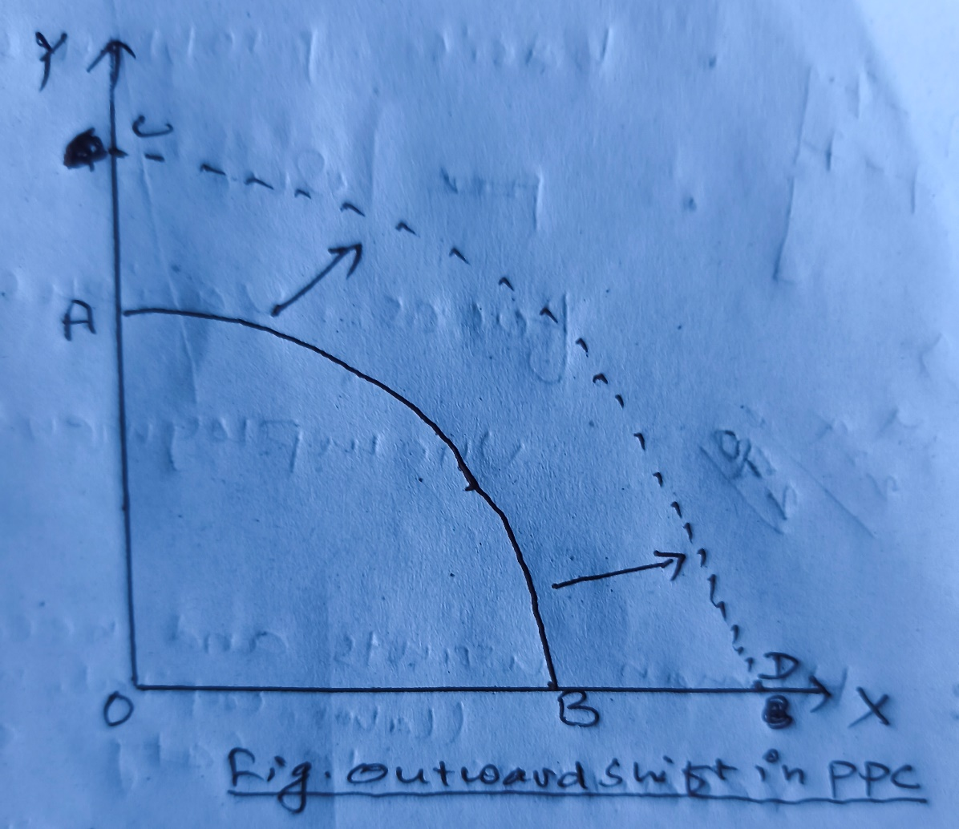

Reasons for outward shift in PPC:
- Improvement in technology
- Increase in the productivity of labor force
- Availability of new raw materials in large quantity
- Increase in investment in capital (machinery, infrastructure etc.)
- Inward/leftward shift in PPC:
when the productive capacity of the economy decreases, PPC shifts inward as shown in figure below:
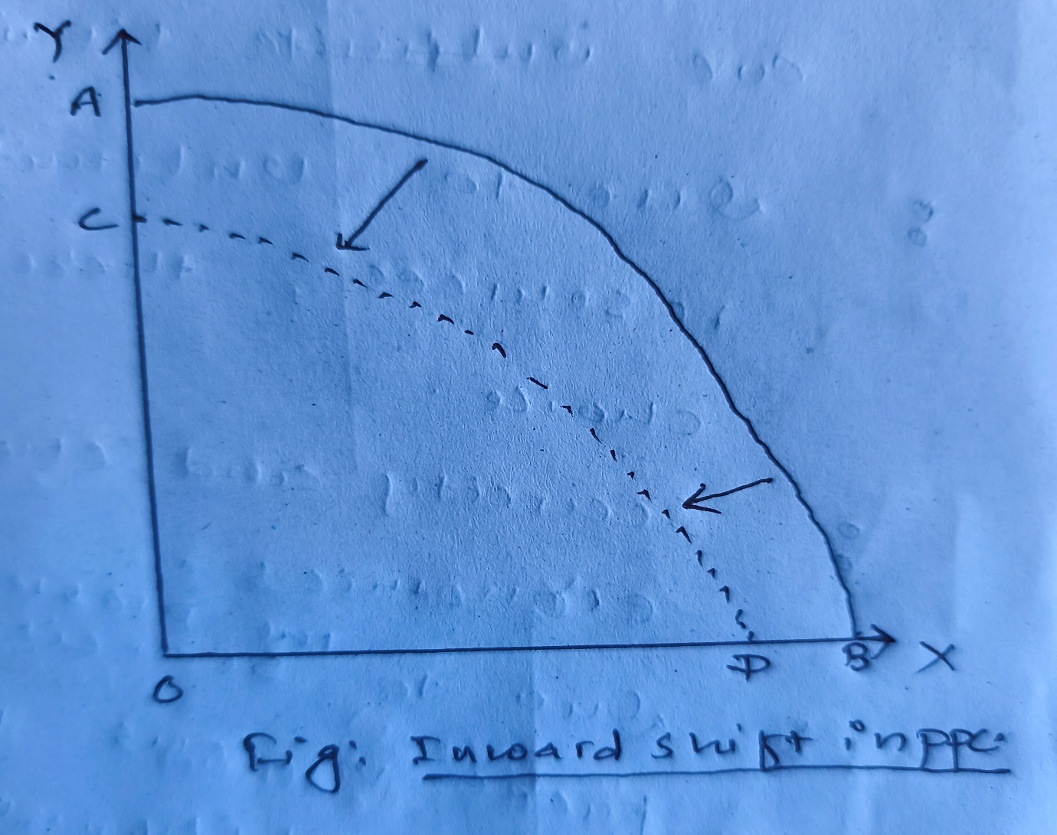

Reasons for inward shift in PPC:
- Technological Backwardness
- Decrease in the productivity of labor force
- Natural disasters
- Shortage of Natural Resources

